SARS-CoV-2 Variants Analysis

Objectives

After discussing with Professor Jo Youngji, we realized that combining the two topics into a single discussion is challenging. The first topic—using the initial growth rate of COVID-19 variants to predict their dominance—is already complex, particularly in terms of the modeling aspects. Therefore, we have decided to address them as two separate research topics. The main points are as follows:

First Analysis
Main topic: How much early share growth rate can predict the future share dominance (across countries).
Deliverable goals:
- To determine optimal observation days for each country by the best model performance (R^2).
- To determine the range of growth rates most contributing to the dominance. (by the coefficient, step function, derived from OTCs)
Utility of the model: our model can predict the future dominance by monitoring the share growth rate of the new variant, based on the specific growth rate range and observation day (e.g. 45 days).
The dominance can be replaced to the duration

Second Analysis
Main topic: Which variants contributed mostly to the hospitalization-infection rate during the Omicron wave across countries.
- To determine whether and to what extent dominant variants were closely associated with the hosp-infec rate.
- To compare group of dominant variants and association with hosp-infec rate across countries.
Utility of the model: 1) To estimate population level epidemic consequence based on nationwide sampled genotype data. 2) To quantify the discrepancy between high share dominance and high hosp-infec contribution.

Methods

Sample Collection and Definitions. The GISAID (Global Initiative on Sharing All Influenza Data) COVID-19 collection serves as a vital global repository for SARS-CoV-2 genomic data, enabling researchers worldwide to track the virus's evolution, transmission, and mutations. Since its launch in January 2020, GISAID has been regularly updated with submissions from various countries, showcasing collaborative efforts in combating the pandemic. Notably, nations such as South Korea, the United Kingdom, and the United States have contributed extensively to the database, reflecting their robust genomic surveillance programs. Data is collected through a network of participating laboratories, public health institutions, and universities, where clinical samples are sequenced and analyzed before being uploaded to the platform. Institutions such as the Korea Disease Control and Prevention Agency (KDCA), the UK Health Security Agency (UKHSA), and the Centers for Disease Control and Prevention (CDC) in the U.S. play pivotal roles in their respective countries' contributions. GISAID remains a cornerstone of international cooperation, fostering transparency and accelerating research aimed at understanding and mitigating the global impact of COVID-19.

The GISAID dataset utilized in this study comprises infection counts from over 3,000 SARS-CoV-2 lineages across the top 30 countries with the highest cumulative infection counts, spanning the period from January 2020 to May 2024. This dataset is recorded daily, enabling detailed day-level analysis of the pandemic's progression and variant-specific impacts. For the purposes of this research, we focus primarily on these top 30 countries, defined by their total COVID-19 infection cases, as they provide the most comprehensive and impactful data for understanding the global dynamics of the pandemic. By concentrating on these countries, the analysis gains greater relevance and precision, reflecting the regions with the most significant epidemiological and public health implications. This targeted approach allows for deeper insights into the interplay between variant evolution, infection trends, and geographic-specific factors, making the findings highly valuable for both global and regional pandemic responses.

Inclusion/Exclusion criteria.
In the variants’ dominance prediction analysis, to enhance representativeness, we classified over 3,000 SARS-CoV-2 lineages based on their parent lineages and ancestors. The goal of this classification was to aggregate the vast number of individual lineages into a manageable set of representative groups, ensuring that each classified lineage reflected a broader category of related lineages. To focus on the most epidemiologically and clinically relevant variants, we established specific criteria for inclusion in the classified lineages. Each lineage had to have recorded at least 500 infections by August 2022, and its peak prevalence within a country had to account for at least one percent of total infections. These thresholds ensured that the selected lineages were significant contributors to the pandemic's trajectory in their respective regions.

Using these criteria, for the top 30 countries with the highest COVID-19 infections, the over 3,000 lineages were condensed into 22 representative lineages. These include well-known variants such as B.1.1.7 (Alpha), AY.4 (Delta), BA.5 (Omicron), XBB.1 (Omicron), and JN.1, among others. The selection covers key lineages that played pivotal roles in the global spread of the virus. Most of the 30 countries included in the analysis contained all 22 classified lineages, reflecting their widespread impact. However, the start dates for lineage detection and prevalence varied by country, highlighting differences in the timing and spread of these lineages across regions. The following table1 gives a general view of the different situation of the different countries among them.
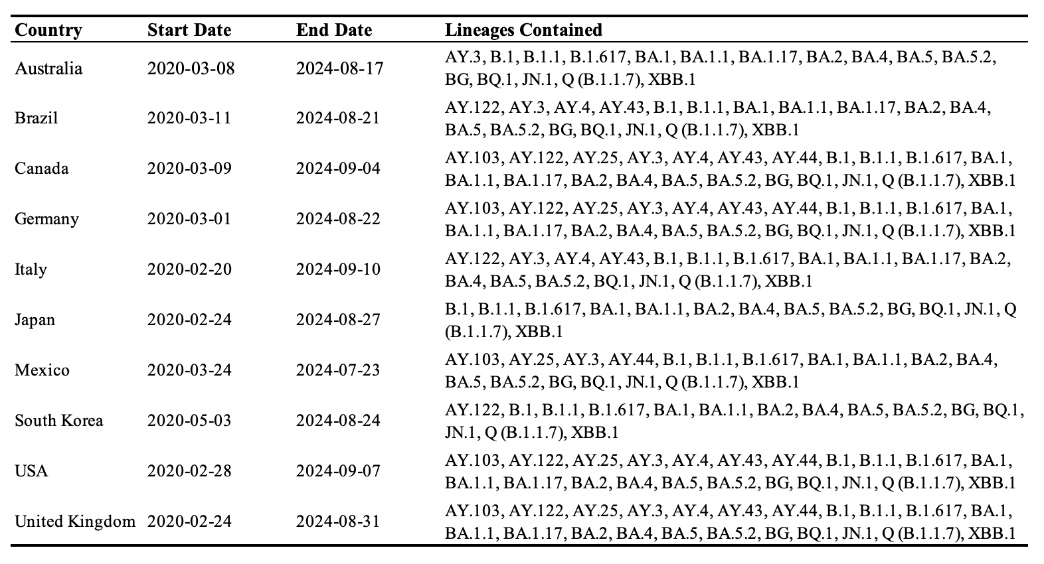
Table1: Description Table of the GASID Data
I noticed an issue while using the provided function to group the lineages. Among the 22 classified lineages, some, like B.1 and B.1.1, appear to have a hierarchical relationship. It seems that B.1.1 is a sub-branch of B.1, while B.1 represents other lineages within this branch, excluding B.1.1.
I’m not entirely sure if this understanding is correct. If it is, should I retain the broader "others" lineage (B.1), or would it be more appropriate to handle it differently?

Statistical Methodologies (Dominance Prediction).
In the analysis of variant dominance prediction, a critical step is defining "dominance." Common definitions include the average country-level share of a lineage or its maximum share during a specific period. The use of country-level share is essential to address large population differences between countries, which could otherwise skew the analysis. However, these metrics have limitations: the average may underrepresent dominance when a variant has sporadic infections outside its peak, while the peak may overstate dominance if a variant achieves high prevalence briefly before disappearing. To address these issues, our strategy defines dominance using two key metrics: the mean share of a variant during its longest consecutive period of prevalence and the duration of that period. This dual approach captures both the sustained influence of a variant and its temporal extent, balancing the limitations of averages and peaks. By focusing on consistent high prevalence and considering duration, this method provides a more comprehensive and accurate measure of variant dominance, enabling better predictions across diverse regions.

After defining dominance as the output for this analysis, the next step was to rigorously define the initial stage of each classified lineage. Initially, the start date was identified as the first recorded infection. However, this often led to inconsistencies, largely due to erroneous records, where single early infections were followed by long periods of inactivity, sometimes exceeding a year. Such cases rendered the initial window uninformative for predictive modeling. To address this, we redefined the start date as the first day of a consecutive week during which the variant consistently recorded infections. This revised criterion ensures the initial stage reflects sustained lineage activity, capturing more reliable patterns for predictive models. A comparison of results before and after this adjustment is shown in Figure 1, highlighting improvements in the consistency and reliability of the initial stage definition.

The aim of this study is to construct a statistical model leveraging the time series of growth rates during the initial stage, after appropriate adjustments, to predict variant dominance at the country level. The presence of frequent zero-share days in daily resolution data complicates direct calculations. To address this, we employ the Savitzky-Golay (S-G) filter [REF], which smooths data by fitting a polynomial to a moving window, allowing for the preservation of critical features such as peaks and trends. Unlike traditional smoothing methods, the S-G filter reduces noise while retaining the intrinsic patterns of the data, facilitating accurate and robust growth rate calculations. This method offers a balance between feature preservation and noise reduction, making it particularly suitable for analyzing irregular time series data. Based on this, the smooth growth rate, of the initial stage, of country-level sharing can be calculated

The next step is to model the relationship between the time series of growth rates during the initial stage and the previously defined metrics of dominance and duration for each variant in each country. The challenge lies in addressing this as a sequence-to-covariate problem. A traditional approach for such tasks is Functional Data Analysis (FDA) [REF], which extends regression methods by allowing the coefficients to vary over time, treating them as functions rather than fixed values. FDA provides a flexible framework for modeling time-dependent relationships. However, a key limitation of FDA in this context is that the fitted time-varying coefficients often fluctuate significantly, particularly near zero. This instability likely arises because, even when multiple variants exhibit similar rapid growth, the timing of their growth can differ. Fitting a single time-varying coefficient for all variants can therefore lead to misleading results, as it assumes a common temporal pattern across variants.

To address this issue, we propose an alternative approach by converting the time series of growth rates into an Occupational Time Curve (OTC) [REF], which captures the cumulative proportion of time a variable spends at different growth rate levels. This transformation shifts the focus from time to the scale of growth rates, allowing the use of FDA with growth-rate scale-varying coefficients. By replacing time-varying coefficients with scale-varying coefficients, this approach improves interpretability and better accounts for variations in growth dynamics among different variants. The OTC conversion provides a robust representation of the growth process, making it a more suitable input for modeling dominance and duration.

Results (1st Analysis)

Adjustment of the initial stage involves removing irrelevant or meaningless data points at the beginning to ensure that the 30-day observation window captures more meaningful and informative data.
Figure 1: Adjustment of the initial stage for each variant. The left panels show the data before adjustment, while the right panels display the data after adjustment. The gray segments represent the first 30-days period.

The Savitzky-Golay (S-G) smoothing procedure is illustrated in Figure 2, with two examples from the United Kingdom and South Korea. In the left panel, the blue "+" dots represent the observed share within the re-defined initial 30-day window, while the blue curves depict the smoothed share obtained through the S-G smoothing procedure. The right panel shows the growth rate of the share, which is derived from the smoothed curves.
Figure 2:S-G Smoothing Procedures and Growth Rate Calculation

Based on the calculations, the Occupational Time Curve (OTC) Transformation was performed for each variant in each country. The OTCs are derived using the following equation:
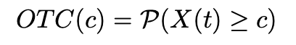
The comparison was then conducted for the main variants observed across all 30 countries included in our analysis. The displayed curves represent the mean Occupational Time Curves (OTCs). For instance, in each country where the Alpha variant (B.1.1.7) is present, the smoothed growth rate and the corresponding OTC are calculated. In the right corner, the duration and dominance information are displayed. A clear pattern emerges for variants with high dominance, the Occupational Time Curve (OTC) decreases rapidly at a 0% growth rate. Examples include JN.1, Omicron (XBB.1), and Alpha (B.1.1.7). This suggests that the growth rate fluctuations of highly dominant variants are minimal, typically showing a slow and steady increase during the initial 30-day observation window.
Figure 3: Mean Occupational Time Curve for Representative Variants on 30-days initial period
To determine the optimal number of days for input, I considered a range from 30 to 60 days, using the prediction R-squared value as the evaluation index. Six countries are presented as examples. The optimal number of days is not necessarily 60. For instance, in South Korea, the United Kingdom, and the United States, an input of 30 to 35 days proves to be optimal.
Figure 4: Model evaluation based on R-squared values using data inputs ranging from 30 to 60 days. The optimal input days are highlighted with red points, representing the highest prediction performance.

The coefficients of the Occupational Time Curve (OTC) can be derived, as shown in Figure 5. The results indicate that the model favors variants with low fluctuation in growth rates, consistent with the earlier discussion.
Figure 4: Model Coefficients of OTCs Obtained through Fused Lasso Regression.

Results (2nd Analysis)

This analysis utilizes the time series of variant shares to predict the hospitalization-infection rate. The problem is framed as a standard high-dimensional time series prediction task. The model applied here is ARIMAX, and the prediction results for example countries are presented below. It is worth noting that the time range of hospitalization records varies significantly between countries. For example, in South Korea, records began in November 2021, while in the United Kingdom, they started as early as April 2020.
To combine these two analyses, I created plots where the x-axis represents the dominance of the variants, and the y-axis represents the coefficient of each variant in the ARIMAX model. These coefficients can be interpreted as the contribution of each variant to the hospitalization-infection rate prediction model. A higher y-value indicates a greater contribution to the hospitalization-infection rate. It is common for variant types to differ across countries. For example, JN.1 appears in the United States but not in South Korea or the United Kingdom, primarily due to the differing time ranges of data collection in each country. From the results, we can know that the most hospitalization-infection rate contributed variants are not necessarily to be dominant.

We are considering writing the first analysis as one paper and the second analysis as another separate paper. However, I am uncertain whether the content of the second analysis is substantial enough to stand alone as an independent publication. I would greatly appreciate any comments or suggestions on this matter, including advice on whether and how these two analyses could be effectively combined into a single cohesive paper. Thank you.
